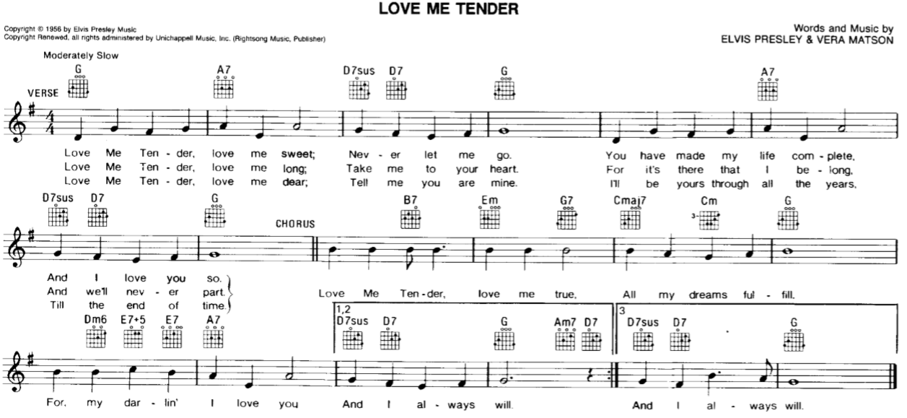

Love me tender,
Love me sweet,
Never let me go.
You have made my life complete,
And I love you so.
Love me tender,
Love me true,
All my dreams fulfil.
For my darlin I love you,
And I always will.
Love me tender,
Love me long,
Take me to your heart.
For it's there that I belong,
And well never part.
Love me tender,
Love me true,
All my dreams fulfil.
For my darlin I love you,
And I always will.
Love me tender,
Love me dear,
Tell me you are mine.
Ill be yours through all the years,
Till the end of time.
Love me tender,
Love me true,
All my dreams fulfil.
For my darlin I love you,
And I always will.

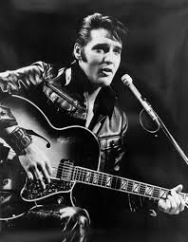
Musician and actor Elvis Presley endured rapid fame in the mid-1950s—on the radio, TV and the silver screen—and continues to be one of the biggest names in rock 'n' roll.

